# THE TITLE OF YOUR PAPER IN CAPITAL LETTERS

***Surname and initials, position, name of the educational institution/organization, city***

***Surname and initials of co-author(s), their positions;***

***scientific supervisor - Surname and full name, Candidate of Technical Sciences, Associate Professor, name of educational institution / organization, city***

**Abstract**

The acceptable length of the paper should be 5 to 6 pages of this template, including the abstract, keywords, figures, formulas, tables and reference list. The main text and headings should be set to 14 font size and single line spacing.

The structure of the paper should meet the IMRAD format, i.e. have the following sections:

─ “Introduction”;

─ “Research method (methods or techniques)”;

─ “Results”,

─ “Discussion”;

─ “Conclusions”;

─ “List of References”

Each heading (‘Abstract’, ‘Keywords’, etc.) is indented before it (‘Paragraph’ - ‘add an interval before the paragraph’).

Texts of reports are prepared in Microsoft Word editor, formula editor - Microsoft Equation 3.0 or Math Type. The smallest indices should not be smaller than 9 pins.

**Keywords:** keywords in English

**Introduction**

Your text should be designed with left-alignment without automatic hyphenation.

References to literature should be in square brackets in the text — [1]. For additional author's explanations and comments use footnotes[1].

**Research method**

Figures and graphs - embedded in the text, with captions underneath. Lines on the graphs should be at least 2.5 pt. Resolution of figures - 300 dpi in .jpg format without compression.

Figures are referenced with an abbreviated entry (Fig. 1). We will be grateful if you highlight the reference to your figure in the text with a marker.

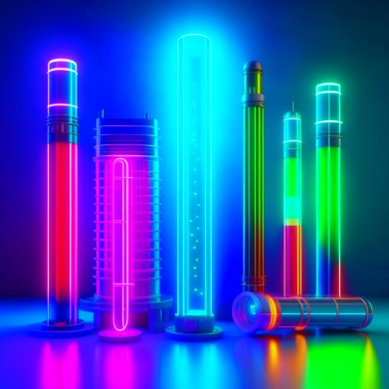Fig. 1. Please Make the caption using Arrial Narrow font, and make the font size 1 point smaller than the size of the main text (13). Do not put a full stop at the end of the caption

**Results**

Describe the results of your research.

In case the figure includes several images, give in the caption a reference to each image as shown in Fig. 2. If you need to refer to a specific part of such a figure in the text, write as follows: Fig. 2*a*.

|  |  |
| --- | --- |
|  |  |
| ***a)*** | ***b)*** |

Fig. 2. If the figure includes two images, provide an explanation in the caption for both one (*a*) and the next (*b*). Do not forget to italicize the letters denoting the parts of the figure

Tables are inserted into the text. Please remember that each table and figure should be accompanied by a caption.

Table 1. Make the title and contents of the table in font size 13. The table title should be aligned in the center. Do not put a dot at the end of the title

|  |  |  |  |
| --- | --- | --- | --- |
|  | Column 1 | Column 2 | Column 1 |
| Row 1 | Value 1.1 | Value 1.2 | Value 1.3 |
| Row 2 | Value 2.1 | Value 2.2 | Value 2.3 |

**Discussion**

In this section, compare the results of your study with those obtained previously and described in the literature.

**Conclusions**

In this section, present the conclusions of the paper. These are clearly stated pieces of information that summarize the research.

**List of references**

1. *Samorodov A.V., Abramova L.V.* Method of description of an arbitrary light source // Proc. of Conf. "Young Lighting Scientists of Russia" at the 10th International Specialized Exhibition on Lighting Engineering and Lighting Technology " Interlight 2004", 01-04.12.2004, Moscow, - Moscow, 2004. - p. 61-62.
2. *Kushch O.K.* Optical calculation of the light and irradiation devices on the computer. - Moscow: Energoatomizdat, 1991. 152 p.

1. All footnotes should be set to 12 font size